

**STAFF FINAL CLEARANCE FORM Name: Arumugam N**

**Emp No: 124391**

**Date of Resignation: 24-01-2024**

**Department**

**Designation: Senior Automation Engineer**

**Date of Joining: 19-10-2023**

**Date of Relieving: 24-01-2024**

**Indicate whether handed over or pending**

**Signature of Functional Head**

**Concerned Dept** * Manual / CD's

* Files / Documents

*Client Credentials if any to be deactivated * Others (Specify)

**Finance**

* Salary Advance * Others (Specify)

**Admin**

* Lease Accommodation * Mobile Phone

* Business Cards * Keys

**Training**

* Library Books

* Training Materials

**System Support Group** * PC

* Internet Connection Domain ID Disabling * Email ID Deactivated Disabling

* Laptop ( with bag and mouse) · VPN Access disabling

**Human Resources** * H1B

* Access Card

* ID Card & HRMS(Deactivate) * Others (Specify)

* Time Sheet Completed date:

**Notice period required:**

**Notice period waiver: (YES/NO)**

**EL Balance as on DOR:**

**Remarks: Timesheet approved by Infosys manager (prasad) from 01-01-2024 to 24-01-2024)** 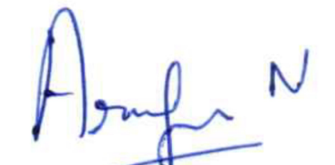

BCTC-ISMS-PR 04 Annexure 6 Rev 1 dt 14/08/23 Internal